JSAF INTERNATIONAL SERIES 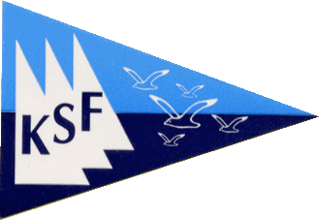
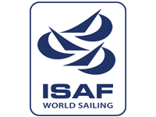
JSAF Enoshima Olympic Week 2011
October 21th – 23th, 2011
Enoshima Yacht Harbor, Fujisawa, Kanagawa, Japan
ENTRY FORM
ENTRY CLOSING DATE: October 12th, 2011
Please fill in on the entry form, and apply to Ms. Mai Higuchi with mail
Ms. Mai Higuchi Email: higmai@kanto470.org
CLASS
COUNTRY
BOAT NUMBER
SAIL NUMBER
CHARTER BOAT | Yes | /No
ENTRY VISA REQUIREMENT | Yes | /No

 | HELMSMAN |  | CREW
NAME | FIRST | FAMILY | FIRST | FAMILY
ADDRESS
MOBILE NO.
PHONE NO.
E-MAIL
DATE OF BIRTH
GENDER | Male | /Female | Male | /Female
CLUB

Promise
“I agree to be bound by the Racing Rules of Sailing and all other rules that govern this event. I understand that the Organizing Authority accepts no responsibility for loss of life or injury, or for the loss of, or damage to, any vessel or equipment. I declare that I have a current certificate of insurance which covers me while racing.”
It approves it.
Date |  | HELMSMAN Name

